IDE Report: Visual Studio 2013

Note: I have done this report on Visual Studio 2013 rather than 2015 due to that is the version of the program that exists on my computers.

# Creating a new project:

* Open Visual Studio, Wait for it to load.
* The first screen to the program will look something like:  
  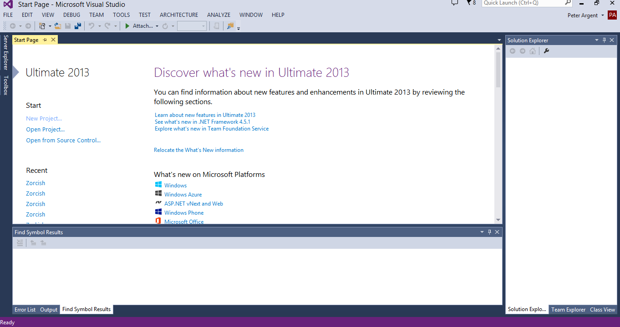
* Under Start, There is a link called “New Project”. Click it.
* We are then showed this screen  
  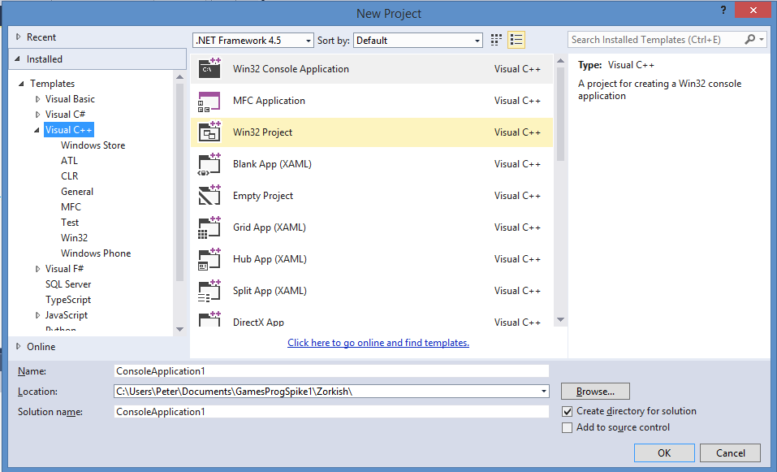
* On this screen are many choices for creating applications. The one we want currently is Win32ConsoleApplication. So click that one, name it, put it in a directory, and click “OK”
* We then get given a wizard that makes the starting files and config of the project  
  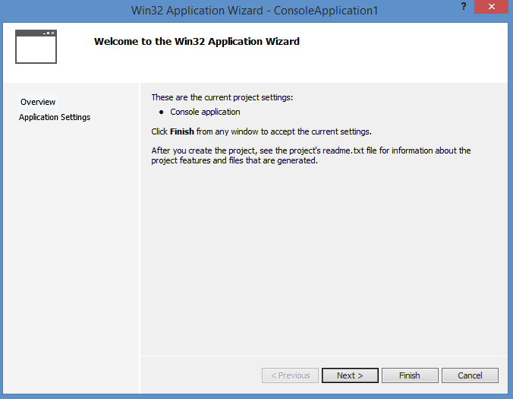
* We want to click “next” on this screen.
* 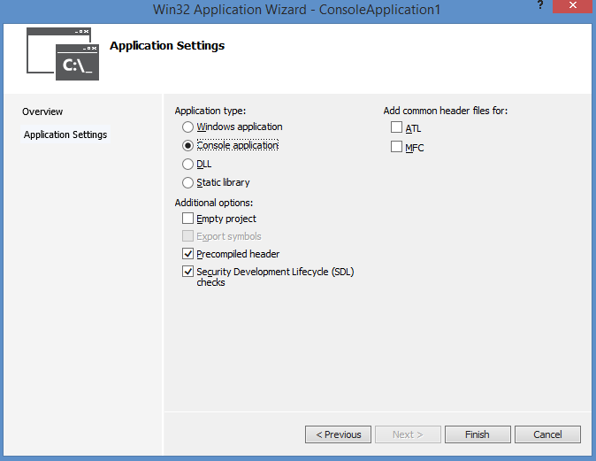
* On this screen we want to check “Empty Project” before we finish.  
  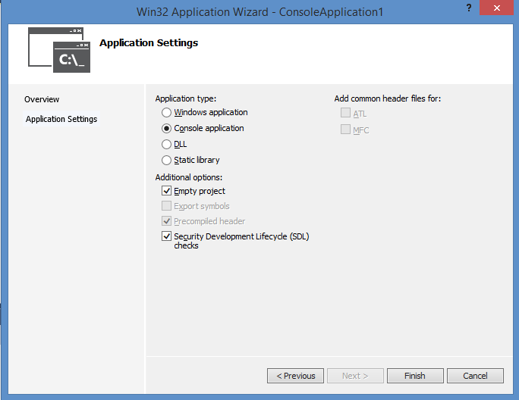
* The following is your empty project  
  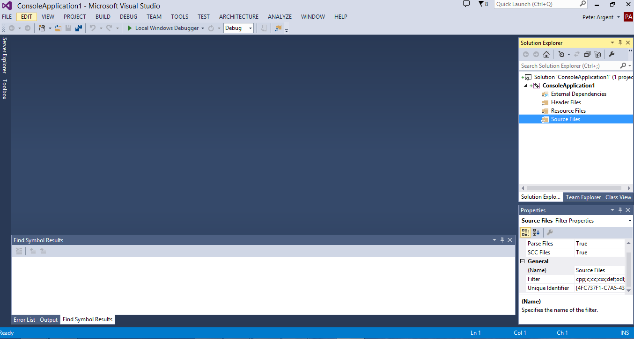
* To add items to the project, right click on the “source files” folder in the solution explorer, and choose “add item” from the context menu.
* We can then add our cpp and header files in the following window.  
  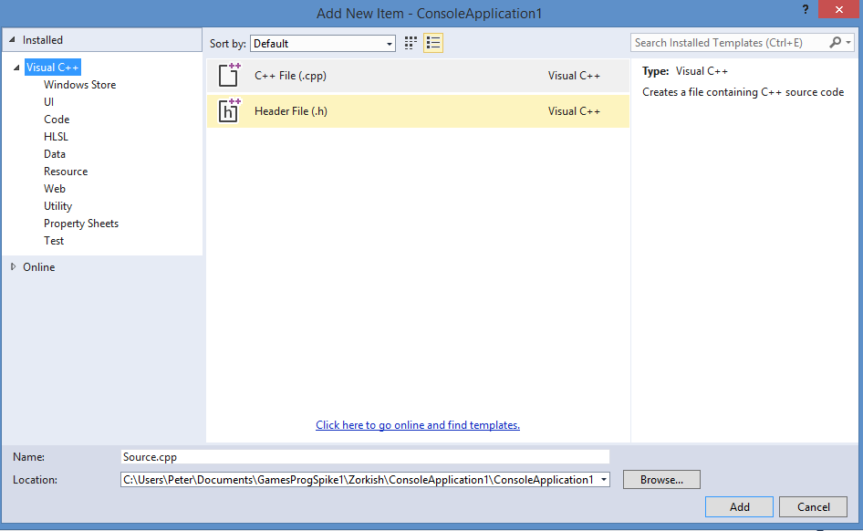

# Creating a Breakpoint:

* To create a breakpoint we just click to the left of the line of code you want to break at  
  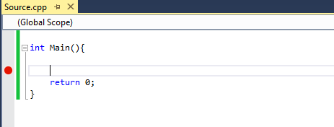
* The Red dot indicates that there is a breakpoint here. When we run the program using the “Local Windows Debugger”, we get the change to the toolbar below, once we hit a breakpoint.
* 
* The red stop will kill the application being debugged
* The Circular Arrow, restarts
* The Straight Arrow allows the program to step one line
* The Arrow to point, makes the program go into the code one level deeper at the current line
* The arrow over point, makes the program continue until it steps through and over the current loop
* The Arrow out of loop makes the program step through its back stack.

NB. During debugging, variables can be found at the bottom left of the screen in a tab called “Autos”. They also can be found in “watch”, which must be set up prior to debugging, and “locals” which are the variables being used in the current function.